|  |
| --- |
| Time Synchronisation protocol |
| How a device can synchronise is time |
| This document is for know how a device can be synchronise to a master clock |

5/4/2016

Contents

I. Method of synchronisation 2

II. Protocol payload 2

III. Type 2

A. SYNC type=1 2

B. Delay Request type=2 3

C. Delay Response type=3 3

D. ACK type=4 3

E. Ping type=5 3

IV. CRC 3

# Method of synchronisation

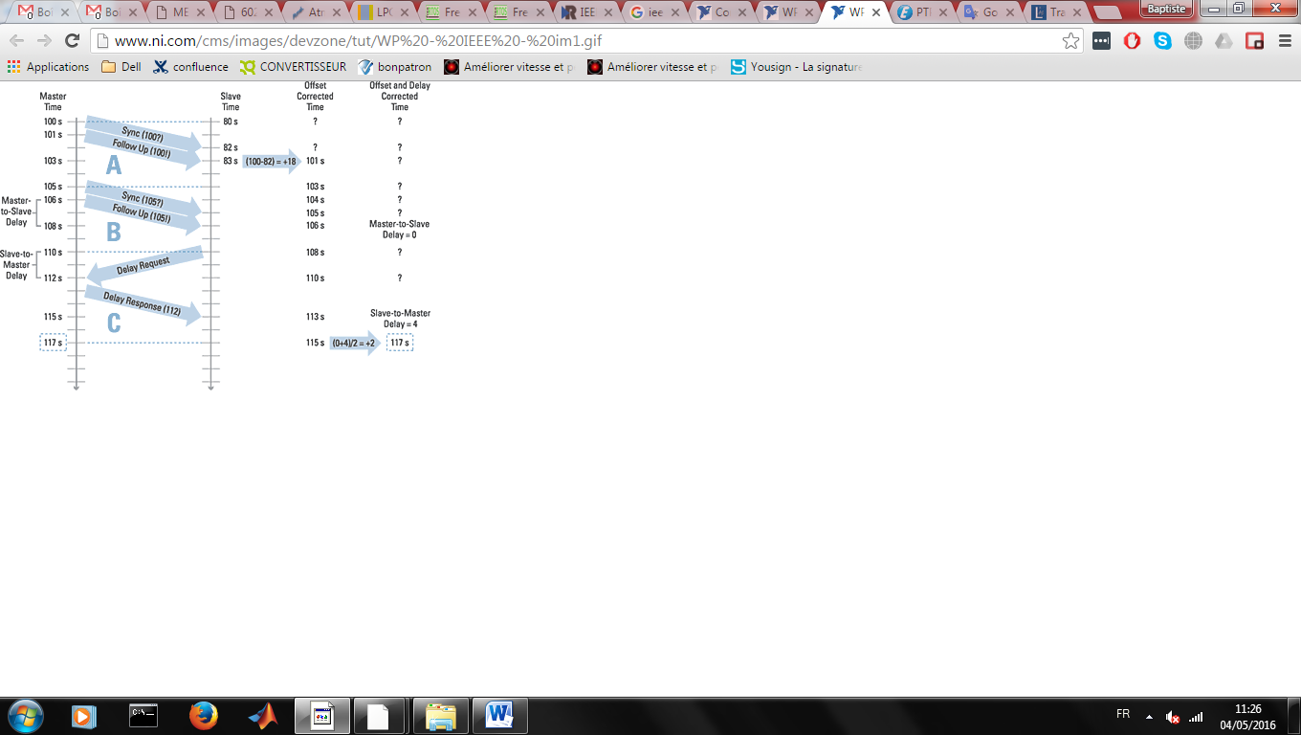

There is 2 time we unknow the offset and the delay of transmission.

For the offset we send a message with the timestamp (T1) of the master when the slaves receive the message he save his timestamp (T2).

**Offset = T2-T1.**

For the delay of transmission time the slave save the time he send a request( T3) when master receive the request he save the current timestamp(T4). He send this timestamp to the slave.

**The delay of transmission= (T4-T3)**

# Protocol payload

Header

Length

type

Data

CRC

ID

* Header a fix Header for the device now that is this protocol (8 bit)
* Lenght length in bytes(8bit)
* ID (8 bit) it’s the unique id of the device.
* Type type of command see section II
* Data data depend of type command.
* CRC :checksum (8bit)

# Type

There is a few types for the time synchronization

## SYNC type=1

Type = 1

Data = currentTime

In sync type master send a broadcast.

Data send his timestamp.

## Delay Request type=2

Type = 2

In delay request no have data.

The master send a delay response after

## Delay Response type=3

The master request send the Request timestamp. This timestamp is the time when the delay request is arrived. And send

Type = 3

id(8)

TimeStamp (8)

## ACK type=4

No data if acknowledge is ok. Else send an error code.

Type = 4

Data = error

There is different error type that exists:

* Error CRC

## Ping type=5

Type = 5

Data = id receiver

Send in the data the device id you want to ping.

# CRC

CRC is calculed, it’s the sum of all the data+id+type.